**Table1**

1Write a SQL query to order records by a rental price  column in ascending order

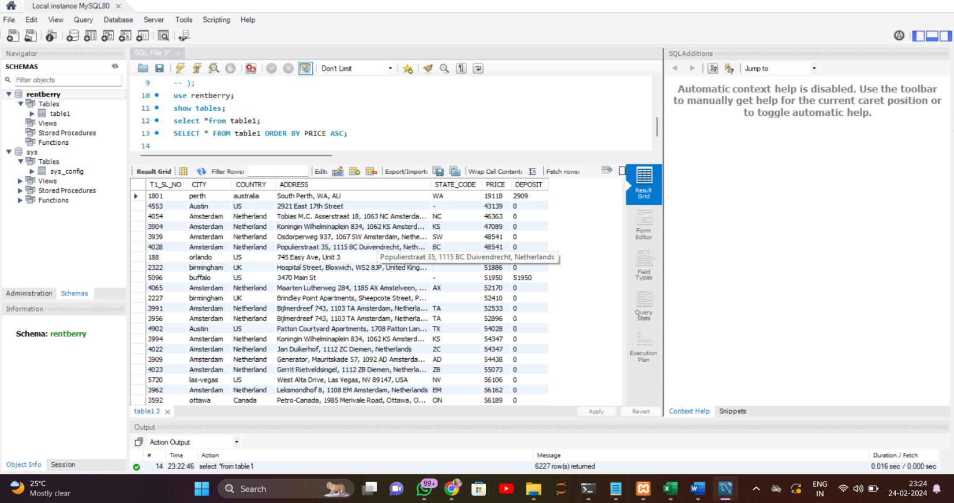

2 Write a SQL query  to select unique combinations of City and State with their average Rental Price.

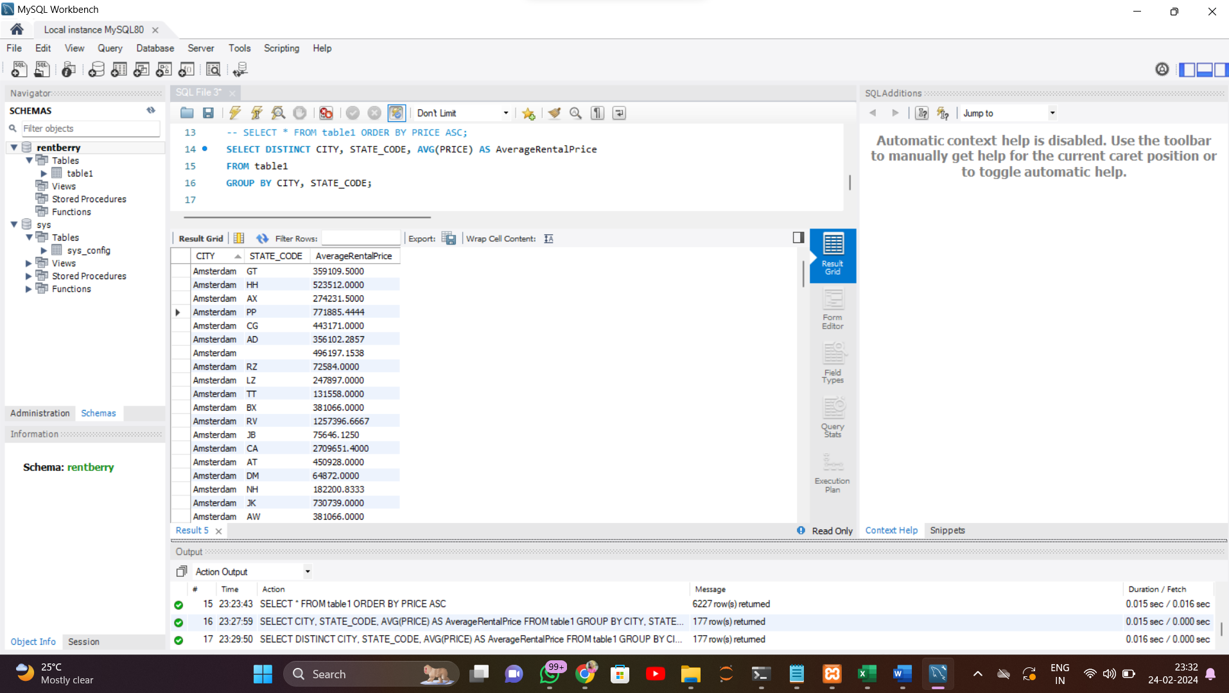

Write a SQL query to select the top 5 highest deposit amounts with corresponding Address and City

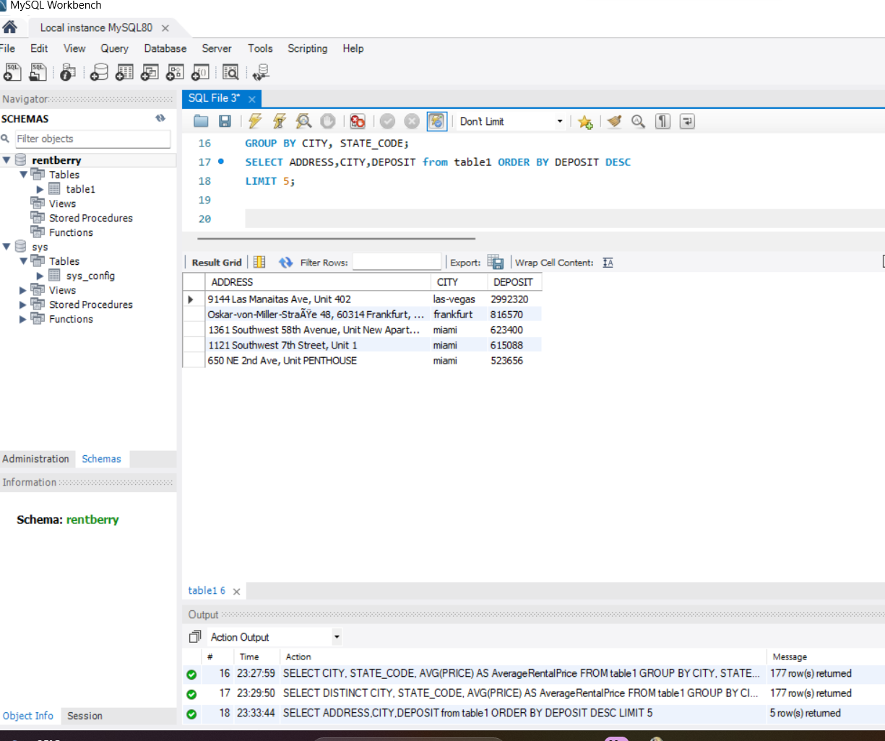

Write a SQL query to select the count of records for each Country along with the total deposit amount

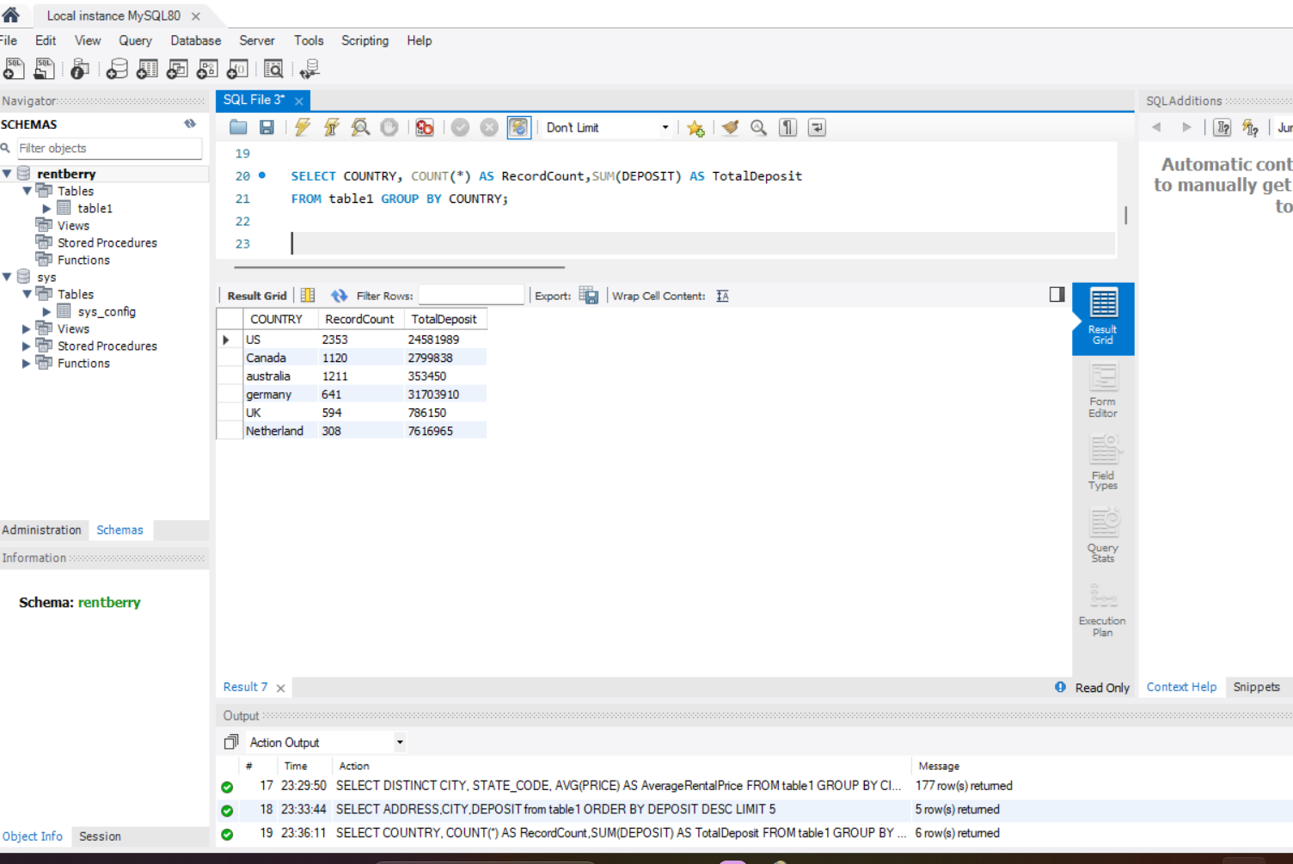

Write a SQL query to select records with a Rental Price higher than the average Rental Price across all records

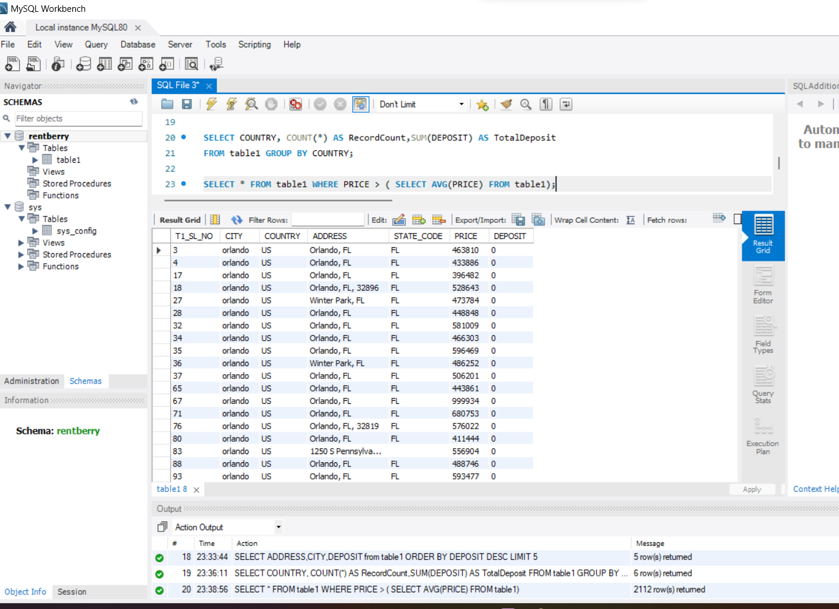

**Table2**

1. Write a SQL query to select the average area for each number of bedrooms.

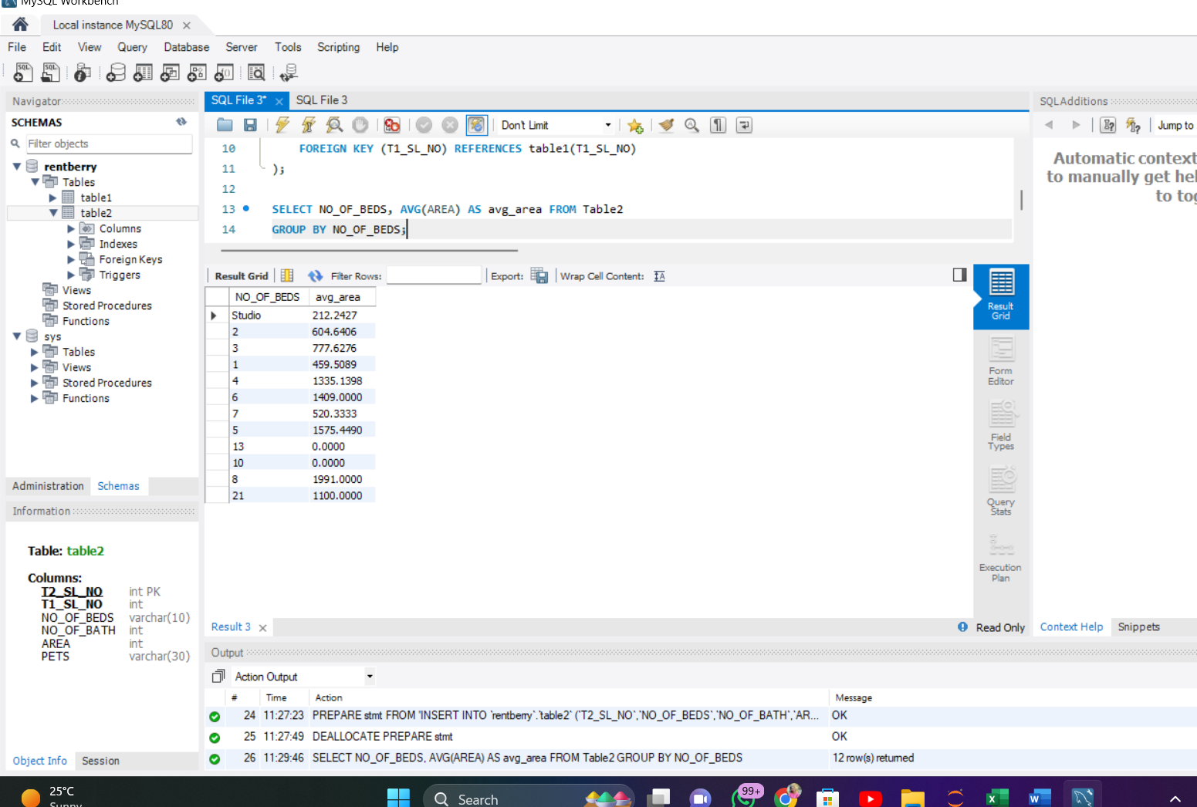

1. Write a SQL query to select records with more than one bathroom and pets allowed.

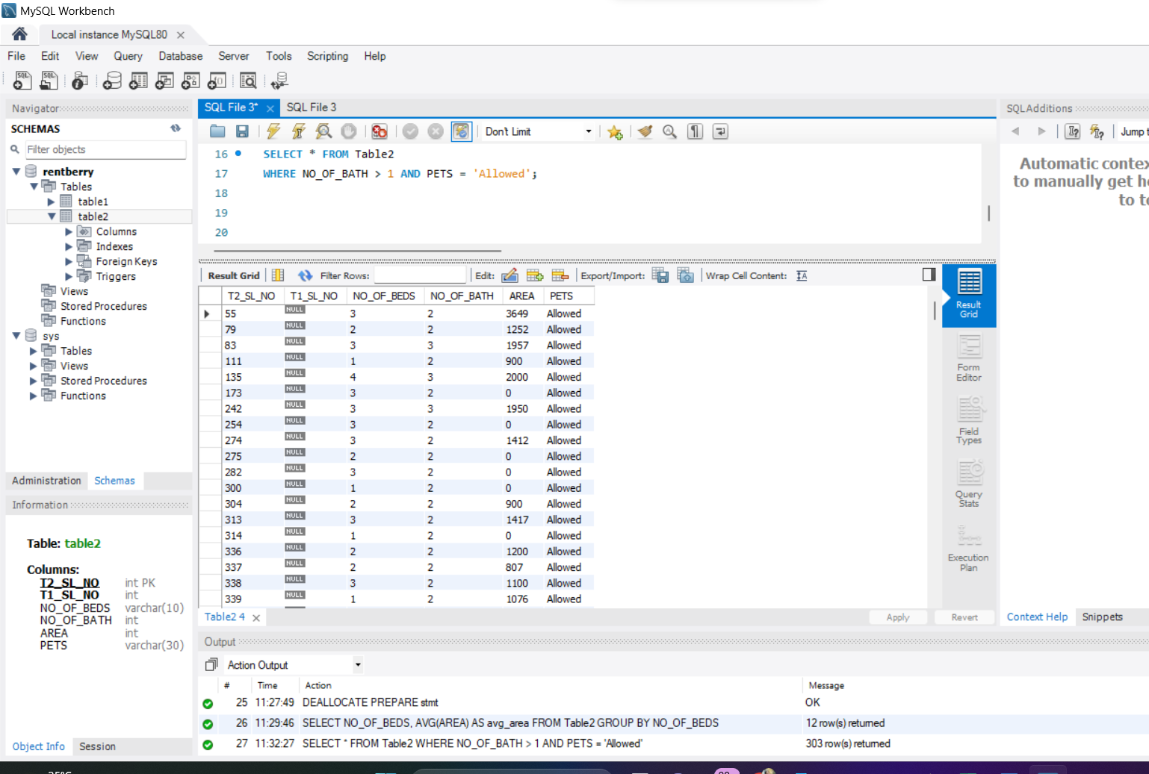

3)     Write a SQL query to select the top 3 records with the highest total area (bedrooms + bathrooms).

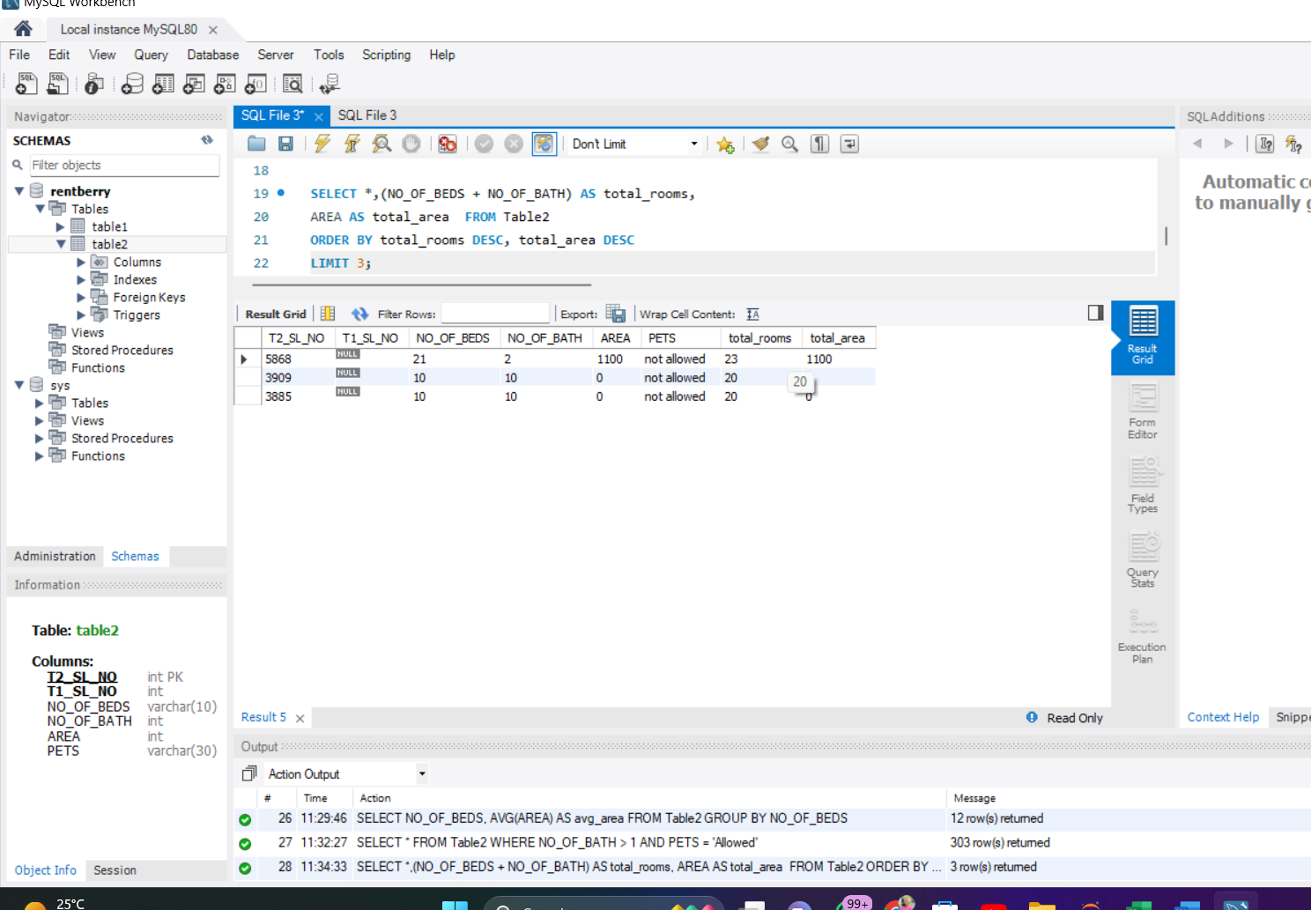

1. ) Write a SQL query to select the count of records for each combination of bedrooms and bathrooms

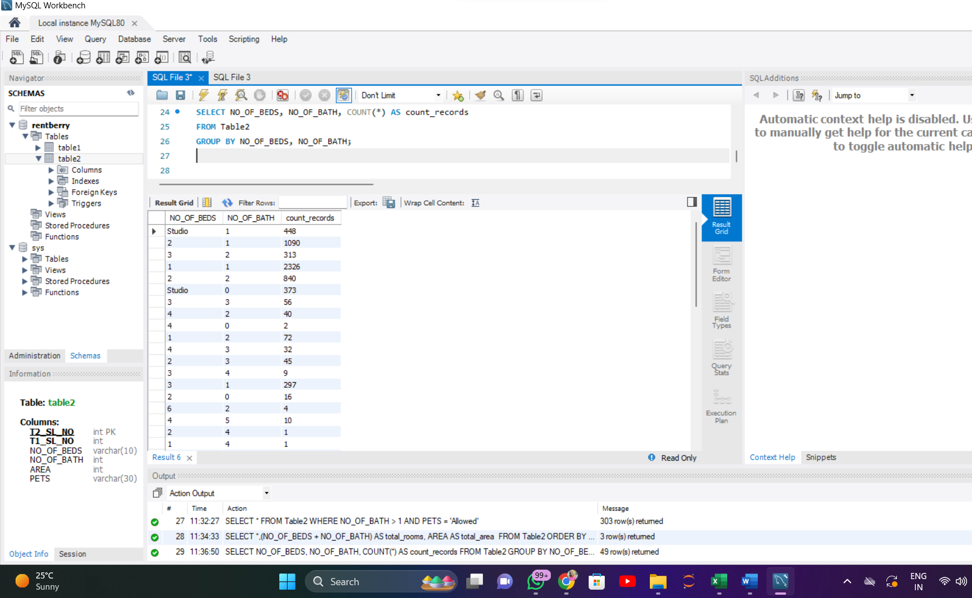

5)      Write a SQL query to  select records with the largest area where pets are allowed .

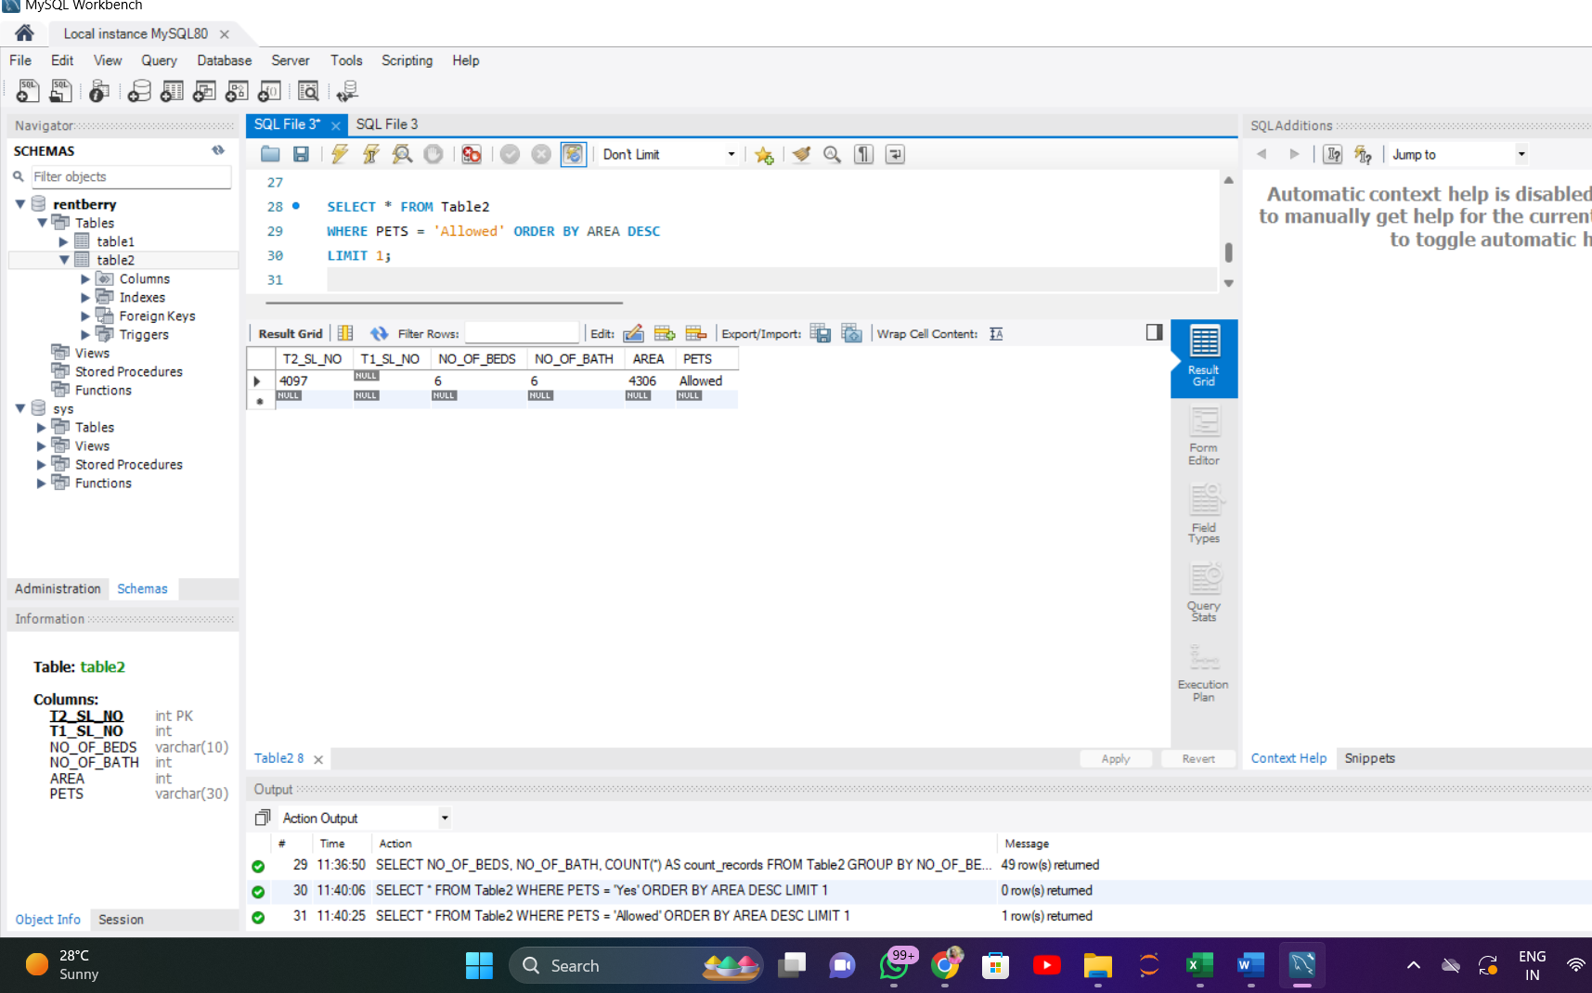

**Table3**

1. Write a SQL query to Select records where both Washer/Dryer and AC are available, and order by Sno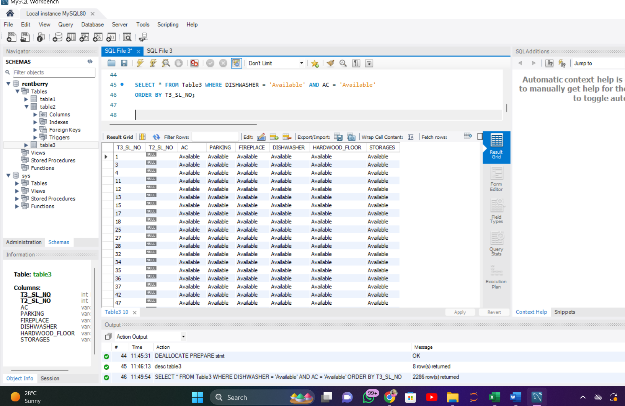

2)      Write a SQL query to Select records where Hardwood floors are available but neither Roofdeck nor Storage is present, and order by Sno in descending order.

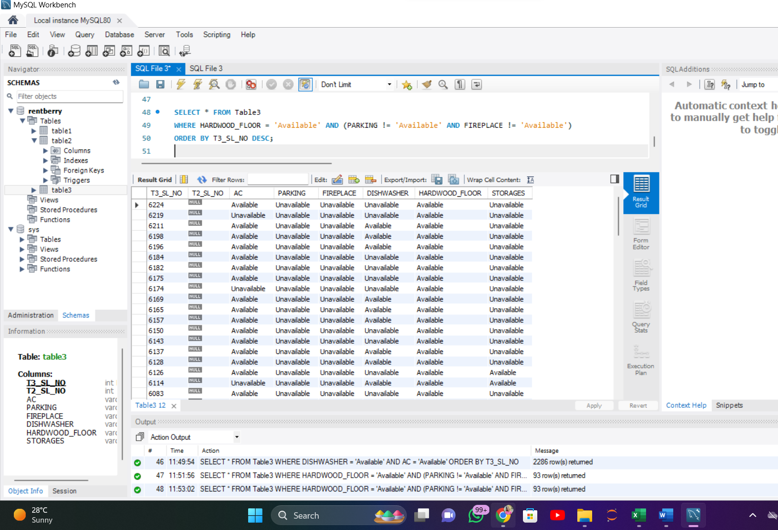

3)Write a SQL query to Select records where at least four amenities (AC, Parking, Dishwasher, Fireplace) are available, and order by Sno .

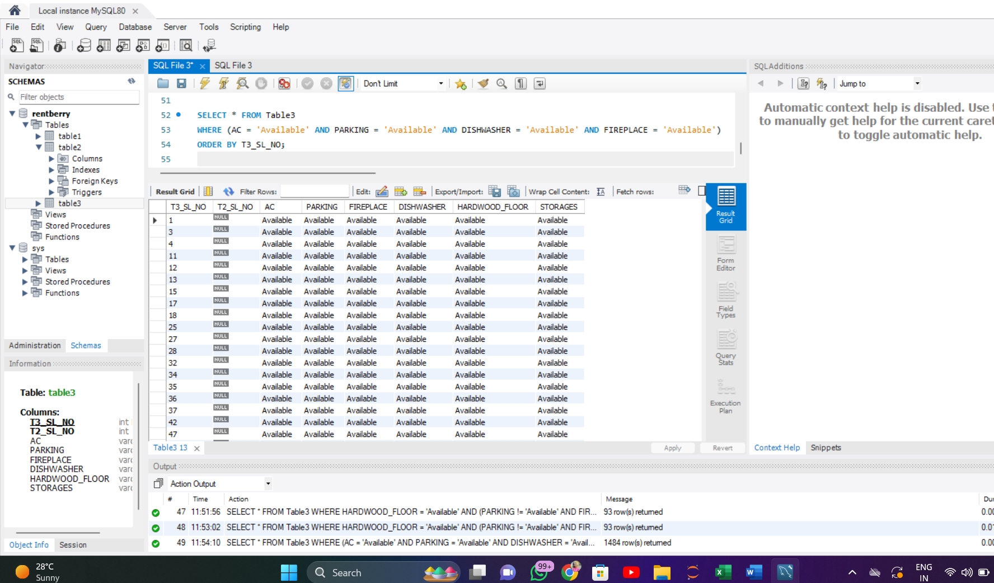

4)     Write a SQL query to Select records where neither Roofdeck nor Storage is available, and include the count of such records.

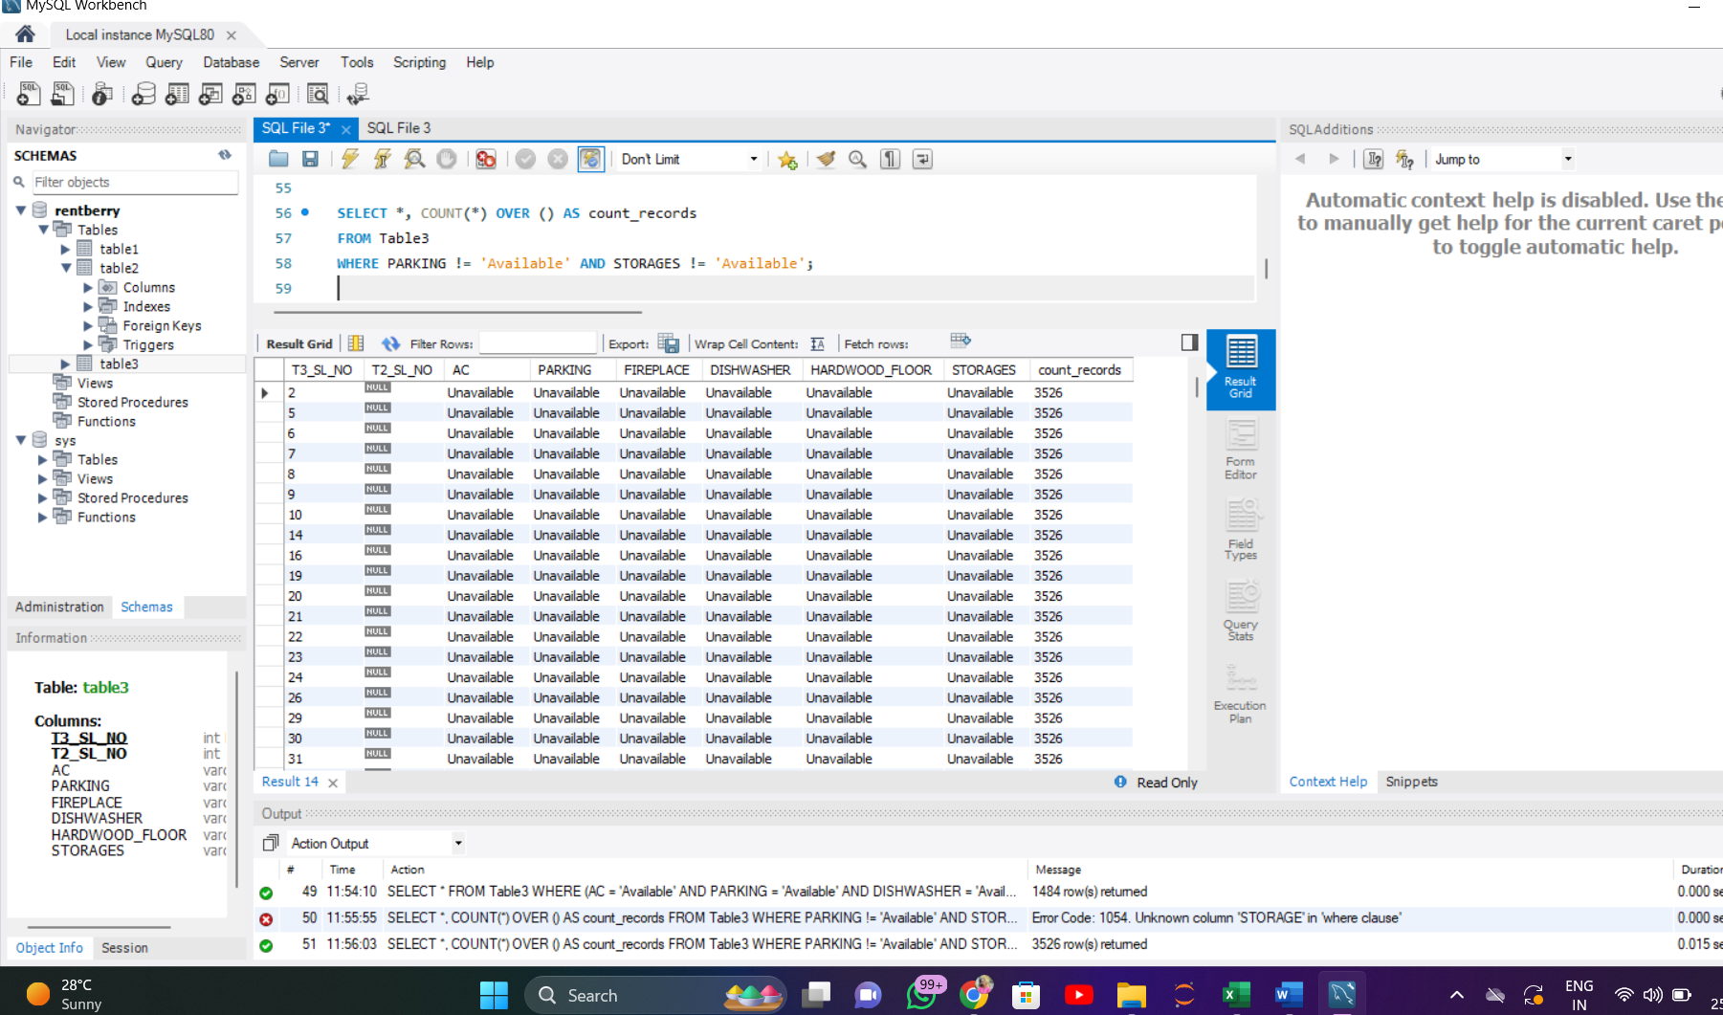

5)     Write a SQL query to Select records with Parking and either Fireplace or Dishwasher, and include the count of records for each condition.

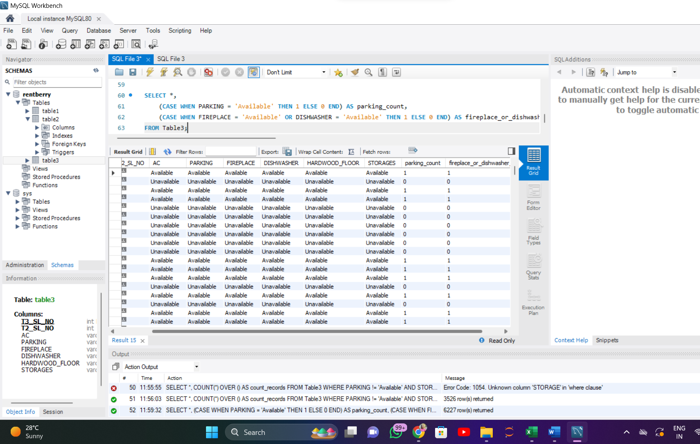

**7  Join SQL Queries  using all 3 tables**

